**ONLINE BUS BOOKING**

**Problem Statement:-**

Online Bus Booking System

**Theory:-**

Online Bus Booking System is Web Based application,That works with in centralised network,It Provides facility to reserved seats,different type of enquiry which need an instant and quick reservation. Buses may be used for scheduled bus transport, scheduled coach transport, school transport, private hire, or tourism; promotional buses may be used for political campaigns and others are privately operated for a wide range of purposes, including rock and pop band tour vehicles.

This project is modularized as the following:

* **Management of Route**
* **Trip Details**
* **Bus Details**
* **Bus Ticketing**

**1. Management of Routes**

This module include information about how we can Manage the routes for a particular bus services so In the case of Route management module we must know the details about route number, number of stops ,fare stages and running time of the particular bus more over we want to manipulate and stored these information successfully.

**2. Trip information**

Each journey is identified as a trip. Each ticket must contain the trip no so that calculation of passenger can be done easily. Here in this section we want to know start time and route no of the bus this information can be manipulate and stored successfully.

**3. Bus Detail**

In this module all bus details are stored and manipulated, in bus detail module contains minimum charge, type, depot, fare increment, bus number, and passenger’s states (child or adult) are manipulate and stored.

**4. Bus Ticketing**

Ticketing is the most important module in this Project which uses all the tables together and calculates fare for the passengers. Venting the tickets is done using the route number, bus type, beginning stop, end stop, ticket number, persons(Adult/child)rate, date and time also we want to print the all these information. In order to do the calculation data has to be pulled out from stops, bus, trip and route. Number of passengers & the states are entered by the Venter and to produce the tickets.

***Steps:***

1. In Visual Studio select new project
2. Select ASP.Net web application template
3. Name the project as BusBookingProject

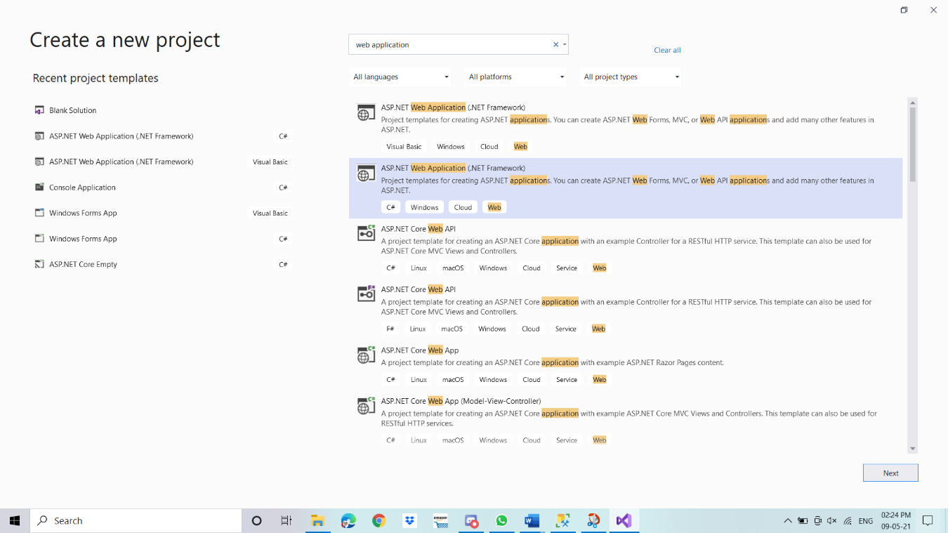

1. Now we create a separate Admin module in which we create all functionality of Admin.
2. Add new Folder name Admin in Project.

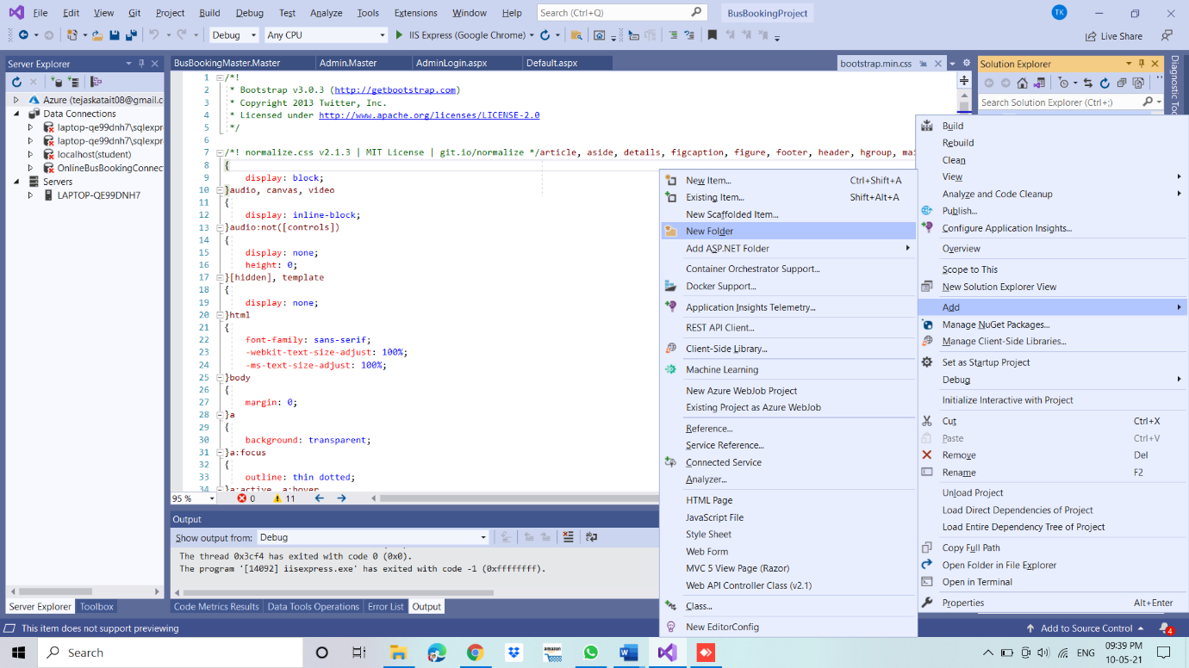

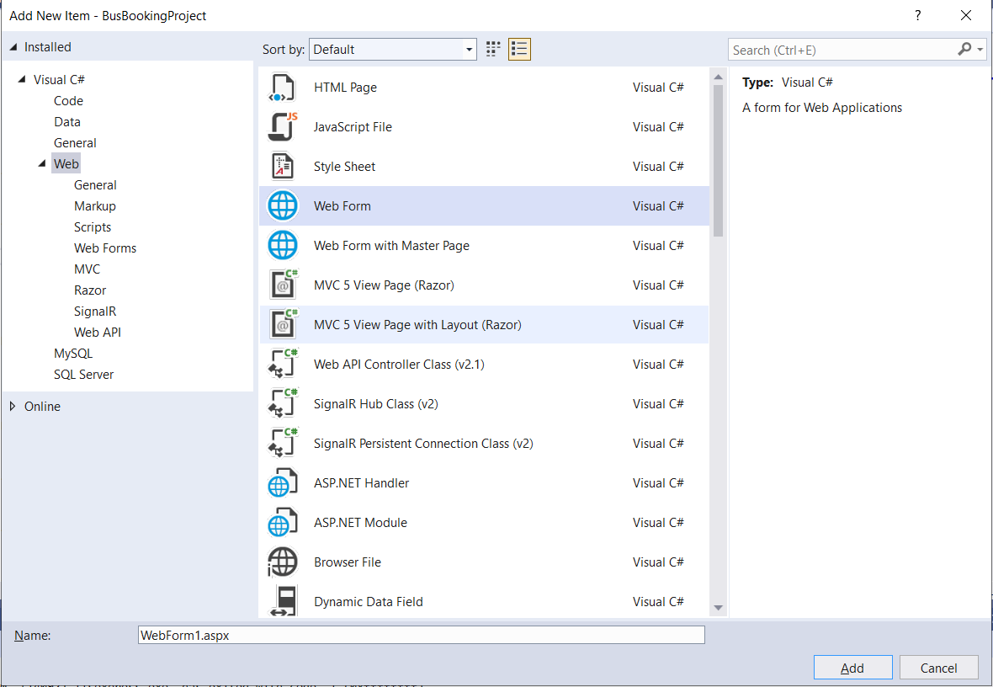

6.As shown in the above photos follow these steps to create new webform and folders

7.Create folders and webforms in Admin section as follows:

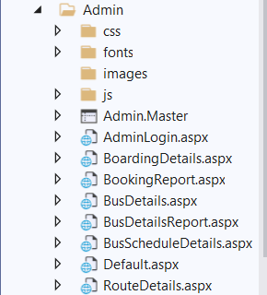

8. Now we will create our user module where main startup pages and other webform will be available.as shown in below picture:

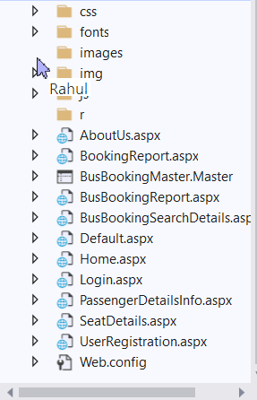

Here is the link of our Github repository:

Now from here you can create your own project or you just open it in your visual studio. Database query is also available there.

Now execute your project by setting Default.aspx webform as startup page...

* So this is our startup page:

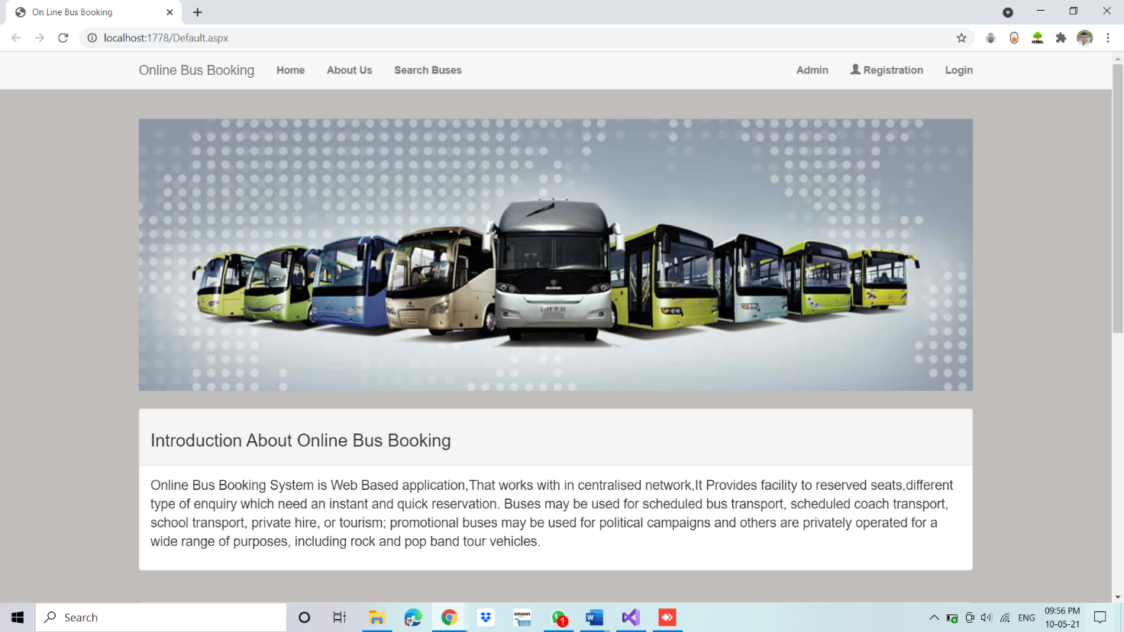

* Now by clicking on Admin button you will redirect to admin section.

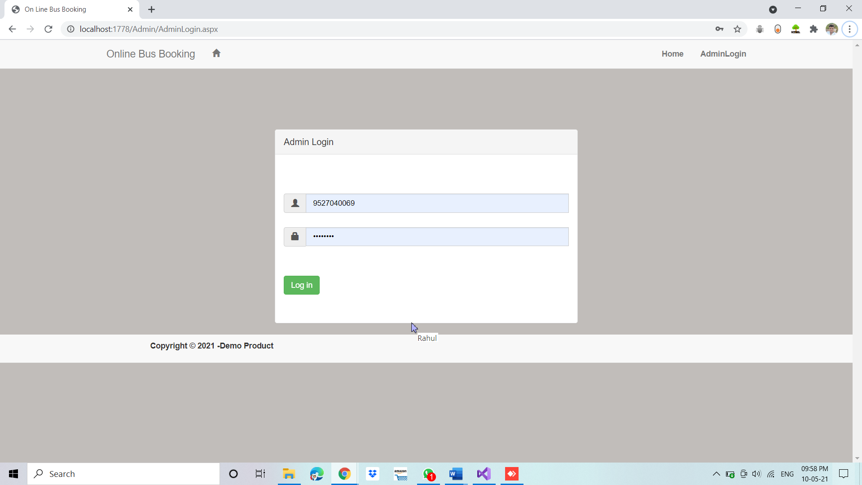

* After login, you will get options like add bus, Route details, Booking Report, Bus details Report.

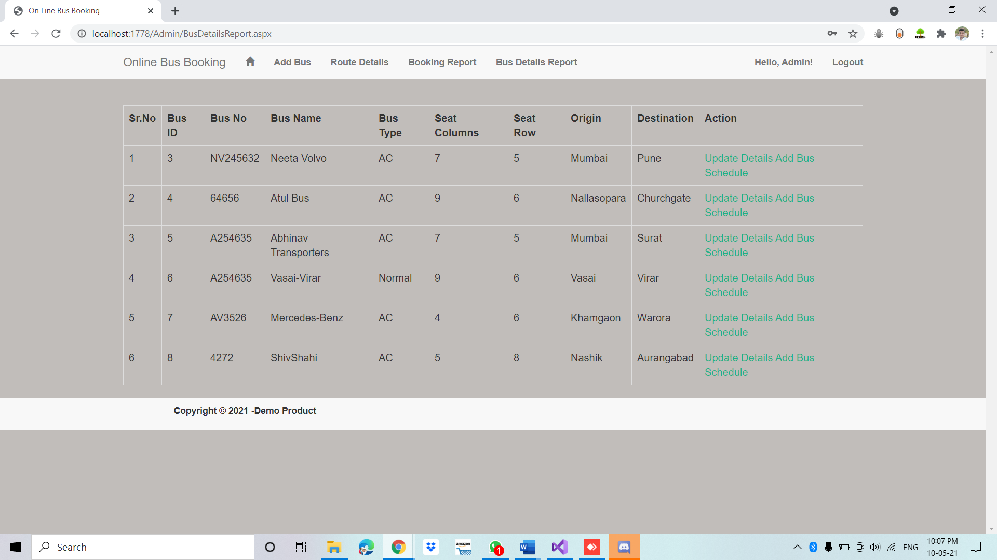

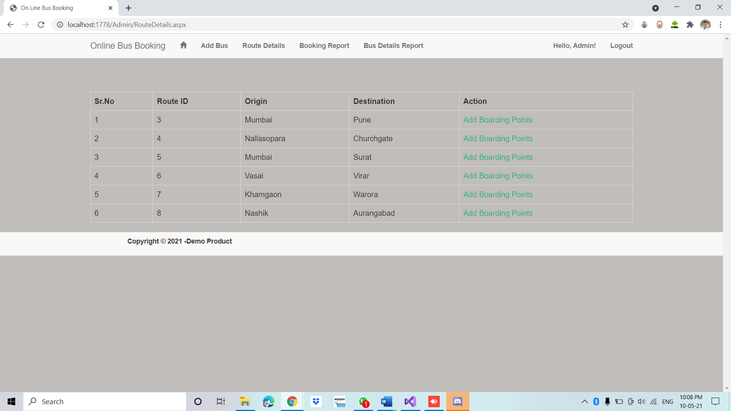

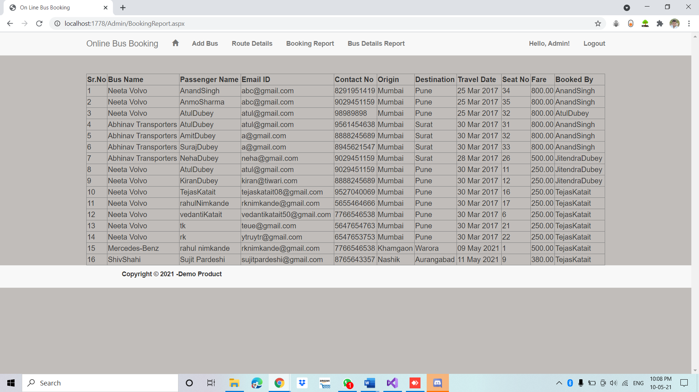

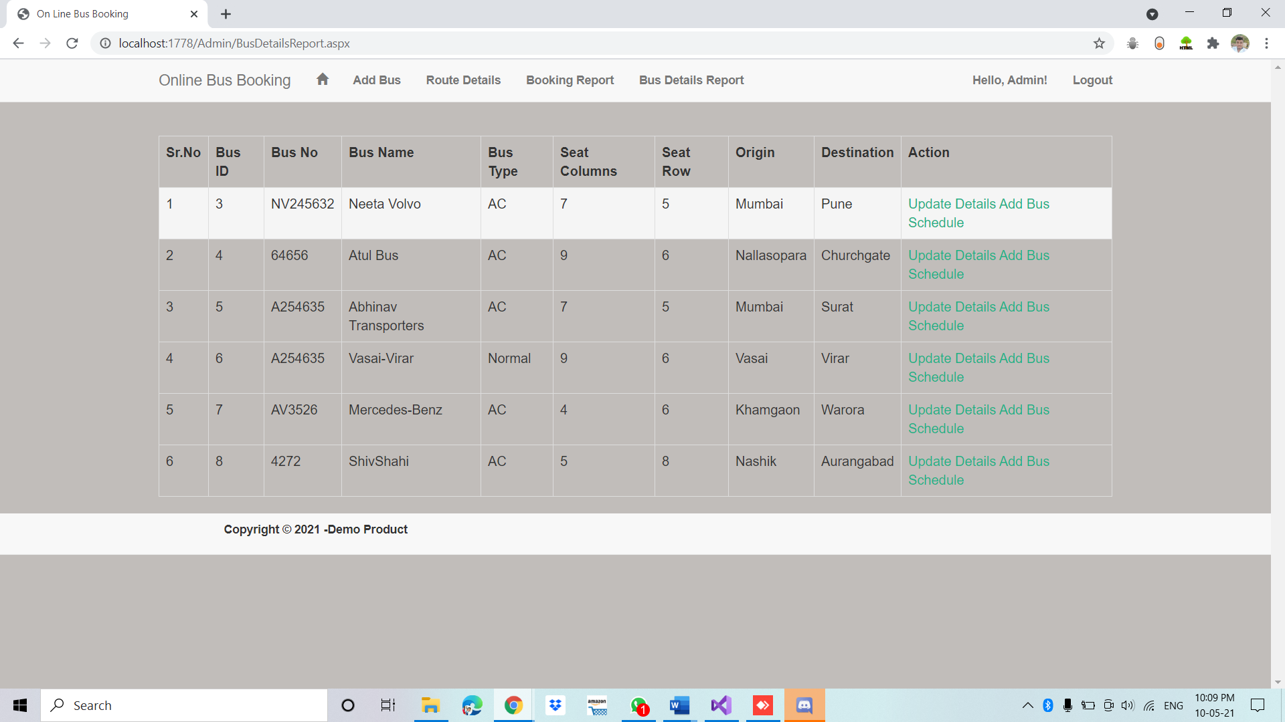

* Now in User module default page you will get registration page and login page.

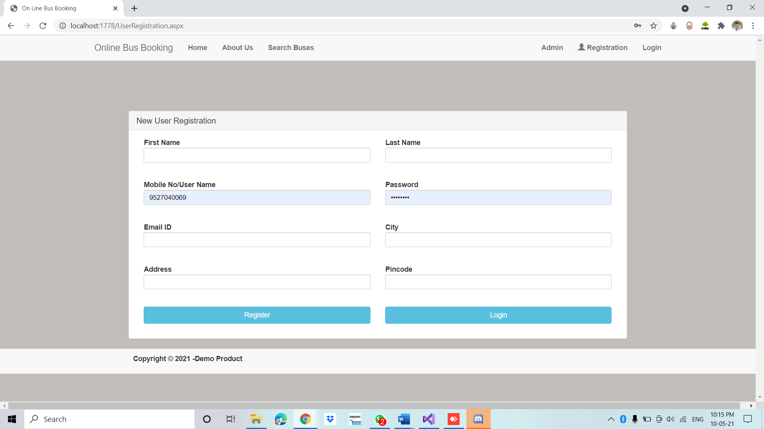

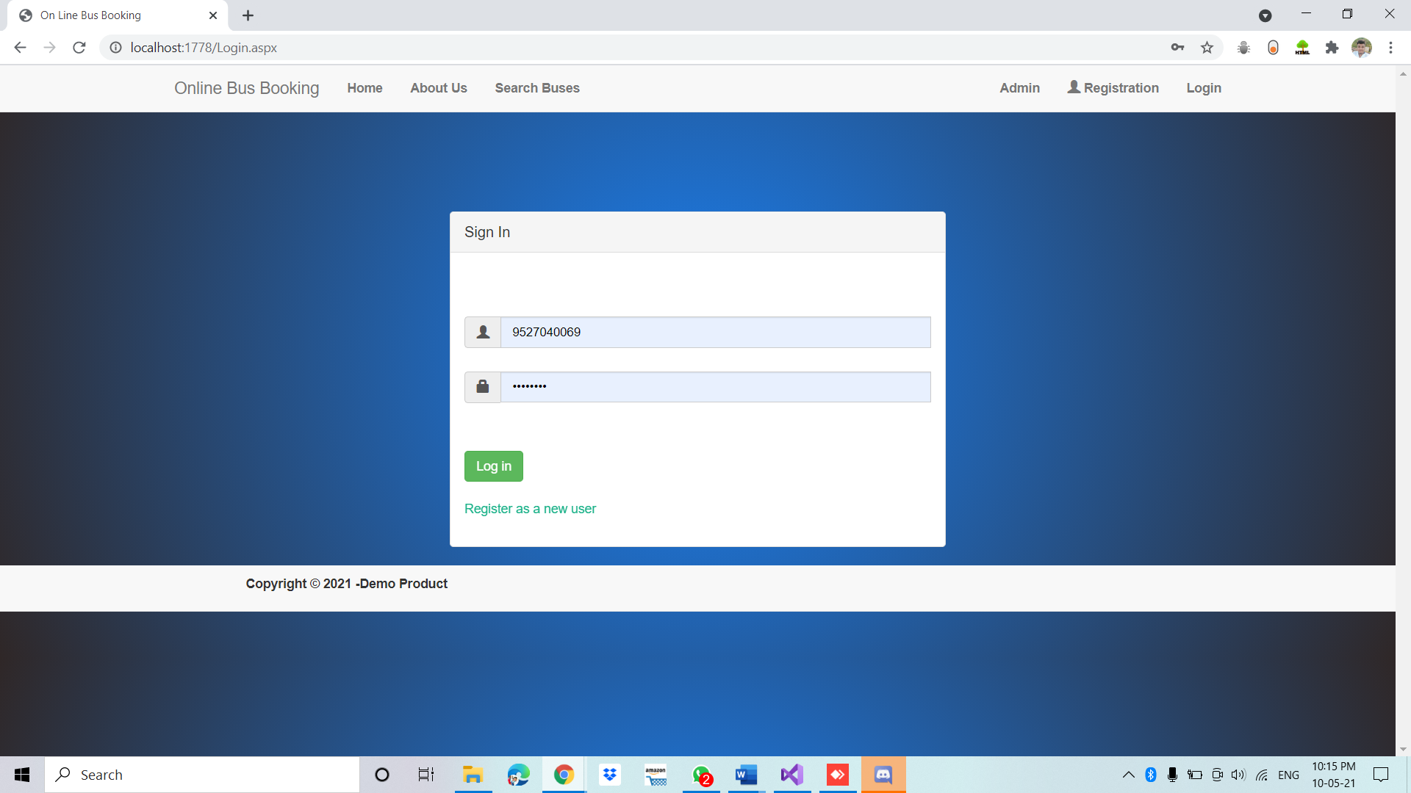

* After registering successfully you will get a username and password then login using it.

After login you will get options like search buses, Booking Report.

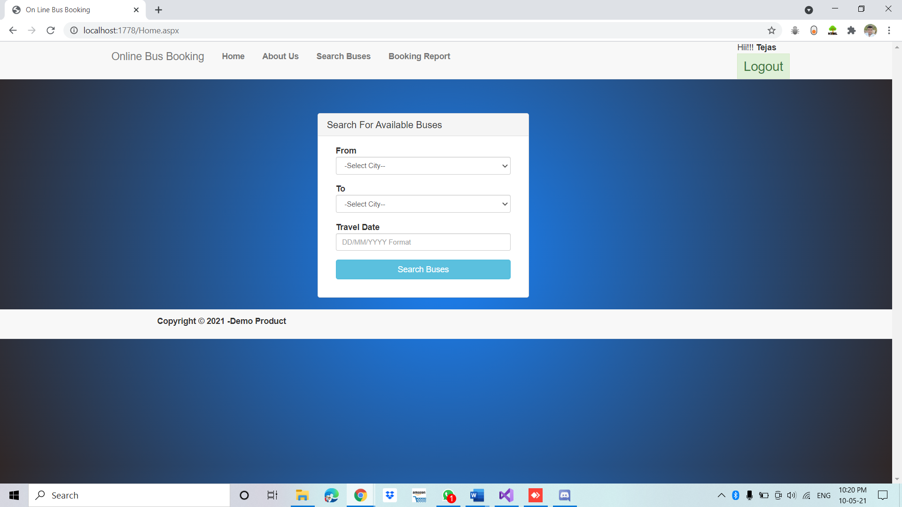

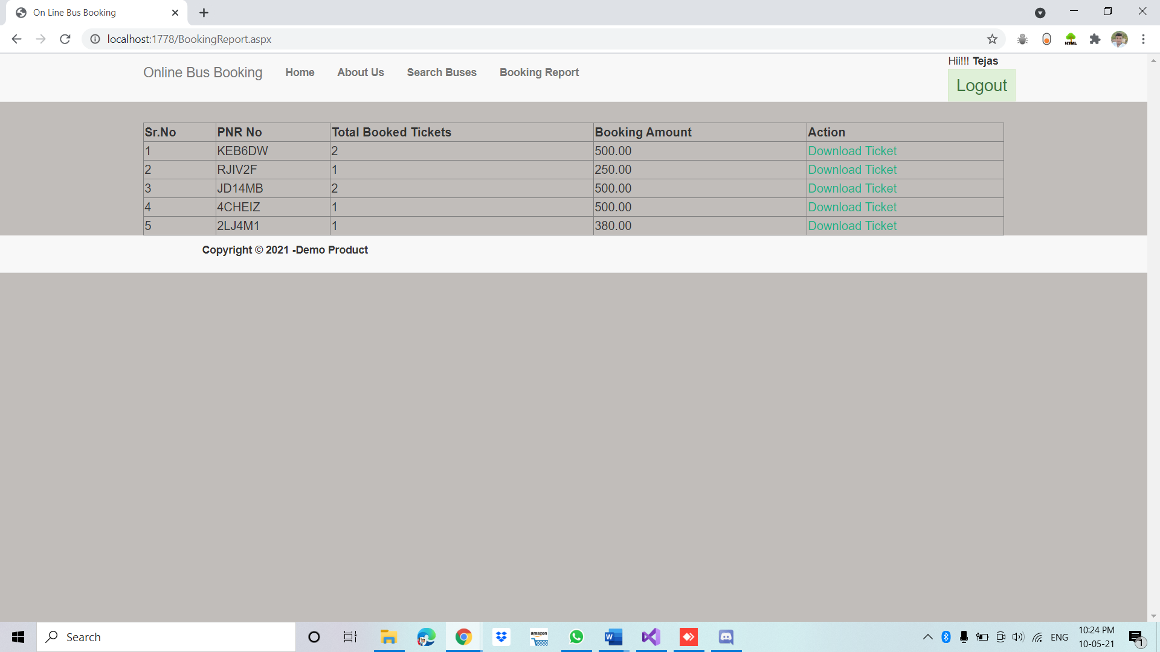

* After searching your desired bus you will get a select option and then you will proceed towards your booking.

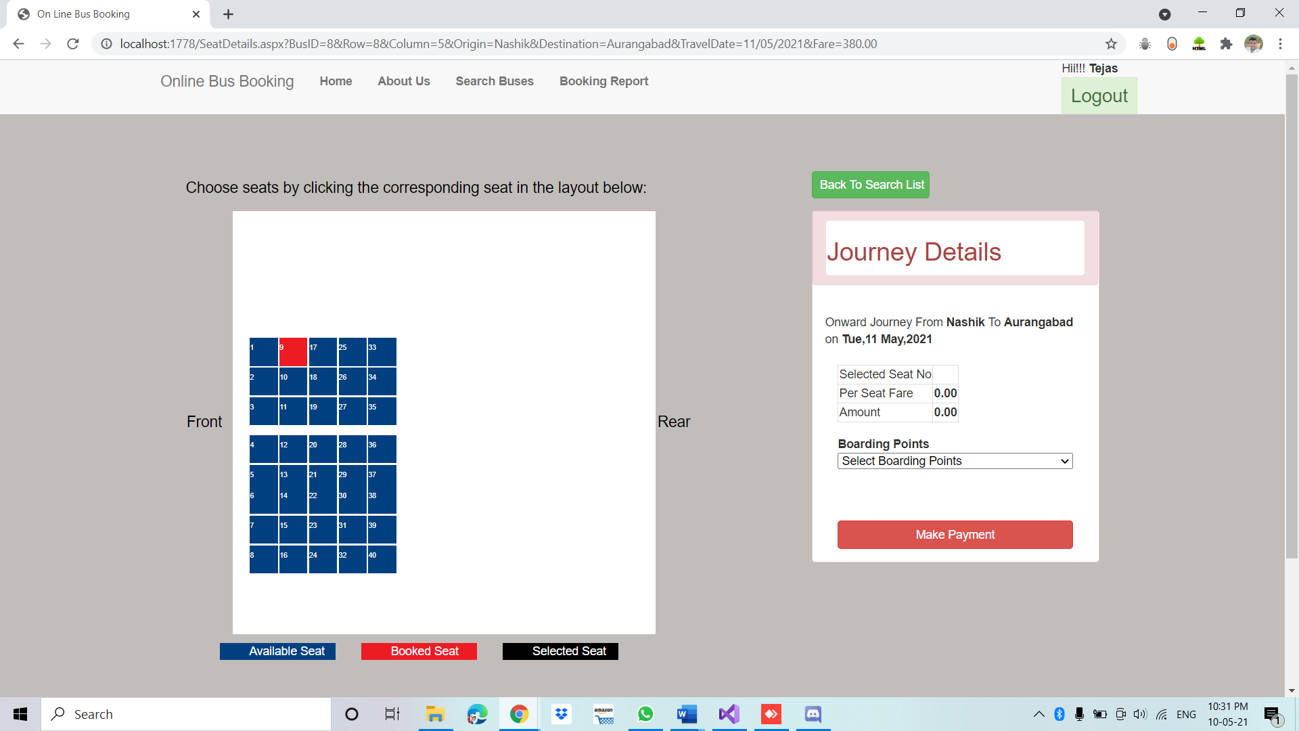

* Then you will have to select available seats and then boarding point and then enter your details and confirm your booking and proceed your payment.

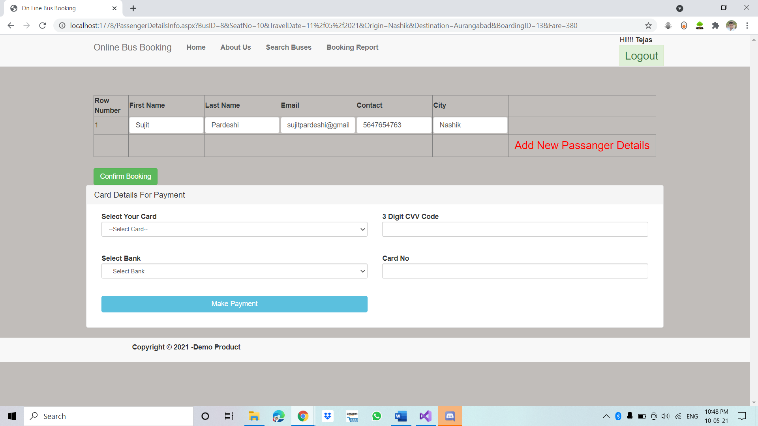

* After making payment you will get a option of download ticket.

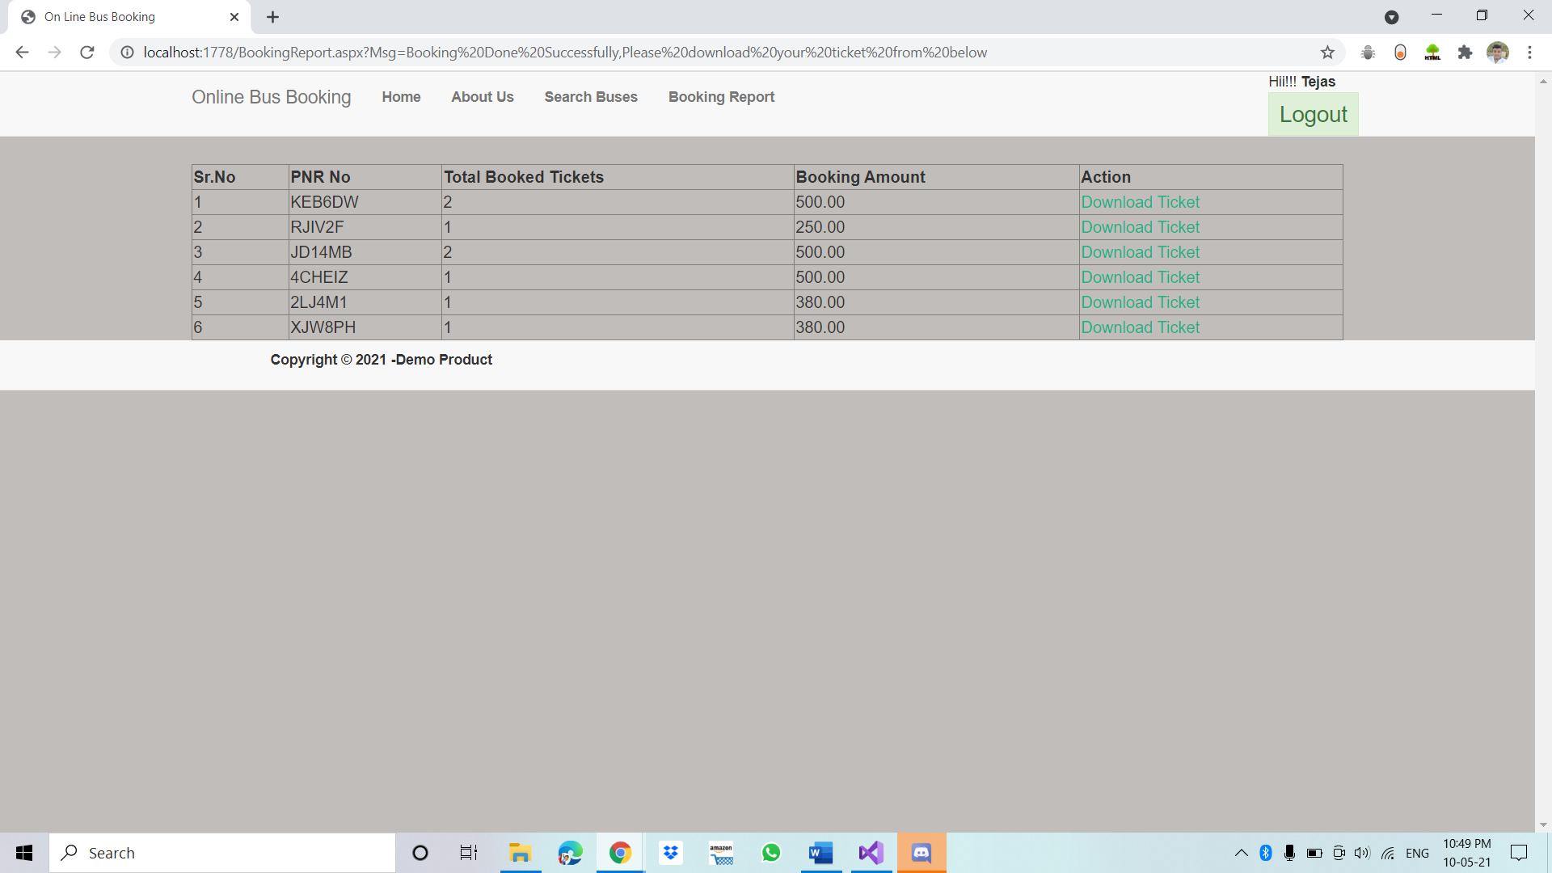

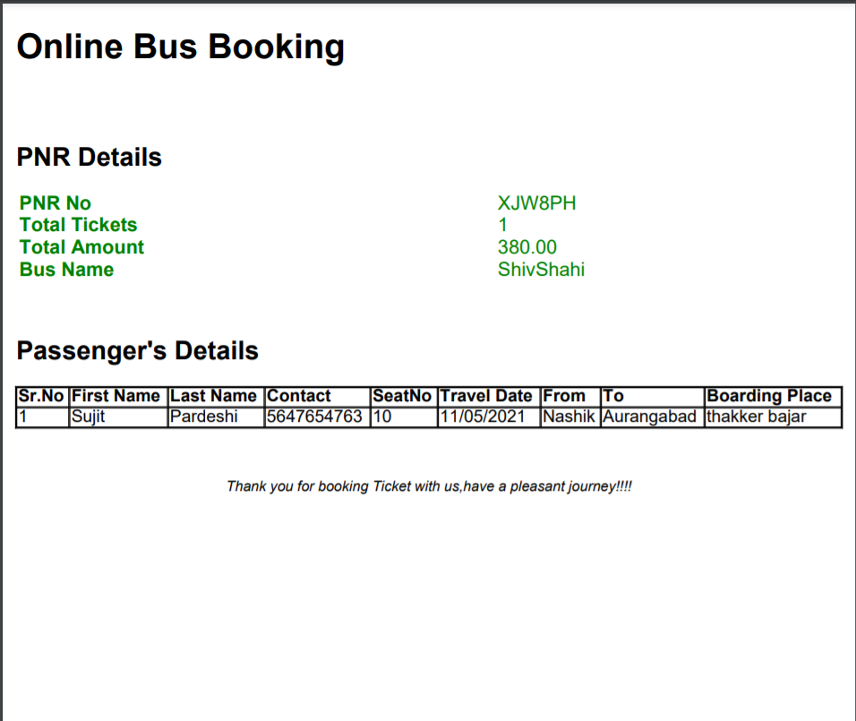

**Conclusion :** We can Successfully created a Online Bus Booking System in Asp.net C#, You can book a bus ticket using this web application, and also you can add your Bus and Bus details in this web Application.